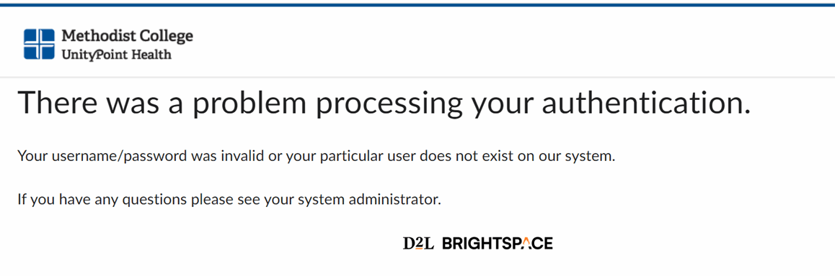
This is a common error when logging into D2L – what happens is that its trying to log in with an expired login session and it fails, but then it doesn’t give you the opportunity to re-enter your information.
In almost every case this can be resolved by clearing you browser cache.
For Google Chrome:
- Go to the 3 dots in the upper right corner
- Hover over History, then another menu should appear which also has an option for History, click that
- In the window that comes up, click Clear Browsing Data on the left side
- In the window that pops up, go to the tab at the top that says Advanced
- Set the time range to all time
- Check every box except “Passwords and other sign-in Data”
- Click the blue “Clear Data” button
- Close all tabs for D2L, email, or anything else that logs in with your @methodistcol.edu account
- Open a new tab and log into D2L
For Microsoft Edge:
- Go to the 3 dots in the upper right corner
- Click History
- Go to the 3 dots at the top of the history menu
- Click clear browsing data
- In the window that pops up, set the time range to all time
- Check every box except passwords
- Click clear now
- Close all tabs signed in with your @methodistcol.edu account
- Open a new tab, sign into D2L
For Safari:
- Go to the Safari drop down menu
- Click clear history
- Choose “All History
- Click Delete
- Close all tabs signed in with your @methodistcol.edu account
- Open a new tab, sign into D2L

